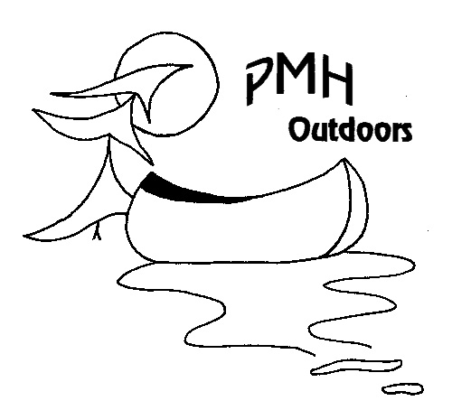
Yoga Waiver and Release

By participating in PMH Outdoors yoga classes, whether in person, online live or from a recording, I agree to these Terms.

I agree that neither I, nor my heirs, executors, administrators, successors or assigns, will hold PMH Outdoors, its owners or teachers, responsible for any injury, accident, illness or harm that may befall me while I am attending a PMH Outdoors Yoga program including, without limiting the generality of the foregoing, any such injury, accident, illness harm or damage caused by defaults of PMH Outdoors, its owners or teachers.

I understand also that no physical activity, including yoga, is risk free. Pat Hawkins is an experienced Yoga Teacher with over 1,000 hours of yoga teacher training. Despite the integrity of our yoga teachers, a student could injure themself through forcing the poses or not performing the poses at their own level of ability. I understand that I can best keep myself healthy and injury free during yoga class by listening to my body and opting out of poses or choosing modifications of poses where my breath becomes halting, and / or there is strain.
Participants may turn their camera on or off for classes offered live online on Zoom. The sessions will be recorded and may be available on the PMH Outdoors website. Students will not have permanent access to the recordings.

Whilst it is not typically the case, from time to time there may be circumstances that prevent a class from running at its scheduled time including but not limited to government restrictions, pandemics, insufficient numbers and/or severe disruption to technology platforms.

The resolution of any disputes arising from or in connection with the relationship or delivery of services, shall be governed in accordance with the laws of the province of Ontario, Canada (other than conflict of laws rules) and the laws of Canada applicable therein. The Courts of Ontario, Canada, shall have exclusive jurisdiction for any disputes.

I acknowledge that I understand and agree to this agreement, and that this agreement is to be binding upon myself, my heirs, and legal or personal representatives.

____________________ _______________________ ______________
Name of Client (print) Signature of Client Date

Please email to paddle@pmhoutdoors when completed – Thank You!

